CHAPTER 1
INTRODUCTION

Introduction to File Structures

File Structures is the Organization of Data in Secondary Storage devices in such a way that minimize the access time and the storage space. A File structure is a combination of representations for data in files and of operations for accessing the data.
A File structure allows applications to read, write and modify data. It might also support finding the data that matches some search criteria or reading through the data in some particular order.

  - Brief history of File Structures
- Early Work:
Early work assumed that files were on tape. Access was sequential. The cost of access grew in direct proportion to the size of file.
- The emergence of Disks and Indexes:
As files grew very large, sequential access was not a good solution. Disks allowed for direct access. Indexes were made it possible to keep a list of keys and pointers in a small file that could be searched very quickly. With the key and pointer, the user had direct access to the large, primary file.
- The emergence of Tree Structures:
Indexes also have a sequential flavour. When they grow too much, they also become difficult to manage. The idea of using tree structures to manage the index emerged in the early 60’s. However, tress can grow very unevenly as records are added and deleted resulting in long searches requires many disk accesses to find a record.
- Balanced Trees :
In 1963, researchers came up with the idea of AVL trees for data in memory. However, AVL tress did not apply to files because they work well when tree nodes are composed of single record rather than dozens of hundreds of them. In the 1970’ s came the idea of B-Trees which require an O(log K N) access time where N is the number of entries in the file and k is the number of entries indexed in a single block of the B-Tree structure. B-Tree can guarantee that we can find an entry among millions of others with only 3 or 4 trips to the disk.

- Hash Tables:
Retrieving entries in 3 or 4 accesses is good but it does not reach the goal of accessing data with a single request. Hashing was a good way to reach this goal with files that do not change size greatly over time. Recently, Extendible Dynamic Hashing guarantees one or at most two disk accesses no matter how big a file becomes.

Data representation in Memory
Record: A subdivision of a file, containing data related to a single entity.
Field: A subdivision of a record containing a single attribute of the entity which the record describes.
Stream of bytes: A file which is regarded as being without structure beyond separation into a sequential set of bytes. Within a program, data is temporarily stored in variables. Individual values can be aggregated into structures, which can be treated as a single variable with parts. In C++, classes are typically used as an aggregate structure.
class Person {
public:
charFirstName [11];
charLastName[11];
char Address [21];
char City [21];
char State [3];
char ZIP [5];};
With this class declaration, variables can be declared to be of type Person. The individual fields within a Person can be referred to as the name of the variable and the name of the field, separated by a period (.).In memory, each Person will appear as an aggregate, with the individual values being parts of the aggregate.

Person
Clerk
FirstName | LastName | Address | City | State | ZIP
Fred | Flintstone | 4444 Granite Place | Rockville | MD | 0001
Fig. 1.1: Output of the simple example program.
  - Fundamental file processing operation
Physical Files
A file that actually exists on secondary storage. It is the file as known by the computer operating system and that appears in its file directory.
Logical File
The file as seen by the program. The use oflogical files allows a program to describe operations to be perform on a file without knowing what physical file will be used. The program may then be used to process any one of a number of different files that share the same structure.
File Operations
In C program, the type FILE is used for a file variable and is defined in the stdio.h file. It is used to define a file pointer for use in file operations. Before we can write to a file, we must open it. What this really means is that we must tell the system that we want to write to a file and what the file name is. We do this with the fopen() function illustrated in the first line of the program. The file pointer, fp in our case, points to the file and two arguments are required in the parentheses, the file name first, followed by the file type.
In C++ , two way we can open file by using constructor or by using member function open().
- Open a file by constructor.
- Member function open().
In C++ we have some built-in functions for dealing with files. You can open a file and read what is inside. You can write a file. That file could be a text file or a picture. Each time we use the open() method and pass the mode as an argument. For reading a file we write “r” and for write we use “w”.
Example for writing into a file:
infile = open('files.txt', 'w') //open file in write mode
infile.write(“Hello”) //write in to a file
infile.close() // closing file
Example for reading from a file and display:
infile=open(“files.txt”,’r’) //open file in a read mode
for line in infile: //reading data from a file
print(line)
infile.close() //closing the file

1.5 File Modes:
‘r’ | Opens a file for reading only. The file pointer is placed at the beginning of the file. This is the default mode.
‘w’ | Opens a file for writing only. Overwrites the file if the file exists. If the file does not exist, creates a new file for writing.
‘a’ | Opens a file for appending. The file pointer is at the end of the file if the file exists. That is, the file is in the append mode. If the file does not exist, it creates a new file for writing.
Rb | Opens a file for reading only in binary format. The file pointer is placed at the beginning of the file. This is the default mode.
r+ | Opens a file for both reading and writing. The file pointer placed at the beginning of the file.
rb+ | Opens a file for both reading and writing in binary format. The file pointer placed at the beginning of the file.
Wb | Opens a file for writing only in binary format. Overwrites the file if the file exists. If the file does not exist, creates a new file for writing.
w+ | Opens a file for both writing and reading. Overwrites the existing file if the file exists. If the file does not exist, creates a new file for reading and writing.
wb+ | Opens a file for both writing and reading in binary format. Overwrites the existing file if the file exists. If the file does not exist, creates a new file for reading and writing.
ab+ | Opens a file for both appending and reading in binary format. The file pointer is at the end of the file if the file exists. The file opens in the append mode. If the file does not exist, it creates a new file for reading and writing.
Ab | Opens a file for appending in binary format. The file pointer is at the end of the file if the file exists. That is, the file is in the append mode. If the file does not exist, it creates a new file for writing.
a+ | Opens a file for both appending and reading. The file pointer is at the end of the file if the file exists. The file opens in the append mode. If the file does not exist, it creates a new file for reading and writing.
ab+ | Opens a file for both appending and reading in binary format. The file pointer is at the end of the file if the file exists. The file opens in the append mode. If the file does not exist, it creates a new file for reading and writing.

CHAPTER 2
REQUIREMENTS AND SPECIFICATIONS
2.1 Purpose of the requirements document
The software requirement specification is the official statement of what is required for development of particular project. It includes both user requirements and system requirements. This requirement document is utilized by variety of users starting from project manager who gives project to the engineer responsible for development of project.
It should give details of how to maintain, test, verify and what all the actions to be carried out through life cycle of project.
2.2 Hardware requirements:
- System : Processor Intel Core i3 or above
- RAM : 1GB or above
- Hard disk : below 500GB

2.3 Software requirements:
- Operating system : Windows 7/8.1/10
- Coding language : PYTHON

CHAPTER 3
DESIGN
3.1 Delineation of Records in a File
3.1.1 Fixed Length Records
A record which is predetermined to be the same length as the other records in the file.
Record 1 | Record 2 | Record 3 | Record 4 | Record 5
Fig. 3.1 :Fixed Length Record
- The file is divided into records of equal size.
- All records within a file have the same size.
- Different files can have different length records.
- Programs which access the file must know the record length.
- Offset, or position, of the nth record of a file can be calculated.
- There is no external overhead for record separation.
- There may be internal fragmentation (unused space within records.)
- There will be no external fragmentation (unused space outside of records)
- Individual records can always be updated in place.
- Algorithms for Accessing Fixed Length Records
- Code for Accessing Fixed Length Records

3.1.2. Variable length record
A record which can differ in length from the other records of the file.
Record 1 | # | Record 2 | # | Record 3 | # | Record 4 | # | Record 5 | #
Fig 3.2 :Variable length record

The records within a file are followed by a delimiting byte or series of bytes.
- The delimiter cannot occur within the records.
- Records within a file can have different sizes.
- Different files can have different length records.
- Programs which access the file must know the delimiter.
- Offset, or position, of the nth record of a file cannot be calculated.
- There is external overhead for record separation equal to the size of the
- There should be no internal fragmentation (unused space within records.)
- There may be no external fragmentation (unused space outside of
- Individual records cannot always be updated in place.
- Algorithms for Accessing Delimited Variable Length Records
- Code for Accessing Delimited Variable Length Records
- Code for Accessing Variable Length Line Records

3.2 Delineation of Fields in a Record
3.2.1 Fixed Length Fields
Field 1 | Field 2 | Field 3 | Field 4 | Field 5
Fig. 3.3: fixed length fields.
- Each record is divided into fields of correspondingly equal size.
- Different fields within a record have different sizes.
- Different records can have different length fields.
- Programs which access the record must know the field lengths.
- There is no external overhead for field separation.
- There may be internal fragmentation (unused space within fields.)

3.2.2. Delimited Variable Length Fields
Field 1 | ! | Field 2 | ! | Field 3 | ! | Field 4 | ! | Field 5 | !
Fig 3.4: elimited variable length fields.
- Fields within a record can have different sizes.
- Different records can have different length fields.
- Programs which access the record must know the delimiter.
- The delimiter cannot occur within the data.
- If used with delimited records, the field delimiter must be different.
- There is external overhead for field separation equal to the size.
- There should be no internal fragmentation (unused space within fields.)

3.3 Representing Record or Field Length
Record or field length can be represented in either binary or character form.
- The length can be considered as another hidden field within the record.
- This length field can be either fixed length or delimited.
- When character form is used, a space can be used to delimit the length field.
- A two byte fixed length field could be used to hold lengths of 0 to 65535.
- A two byte fixed length field could be used to hold lengths of 0 to 99
- In some languages, such as strict Pascal, it is difficult to mix binary

CHAPTER 4
IMPLEMENTATION

What is a file?
File is a named location on disk to store related information. It is used to permanently store data in a non-volatile memory (e.g. hard disk).
Since, random access memory (RAM) is volatile which loses its data when computer is turned off, we use files for future use of the data.
When we want to read from or write to a file we need to open it first. When we are done, it needs to be closed, so that resources that are tied with the file are freed.
Hence, in Python, a file operation takes place in the following order.
- Open a file
- Read or write (perform operation)
- Close the file

How to open a file?
Python has a built-in function open() to open a file. This function returns a file object, also called a handle, as it is used to read or modify the file accordingly.
>>> f = open("test.txt") # open file in current directory
>>> f = open("C:/Python33/README.txt") # specifying full path
We can specify the mode while opening a file. In mode, we specify whether we want to read 'r', write 'w' or append 'a' to the file. We also specify if we want to open the file in text mode or binary mode.
The default is reading in text mode. In this mode, we get strings when reading from the file.
On the other hand, binary mode returns bytes and this is the mode to be used when dealing with non-text files like image or exe files.

Python File Modes
Mode | Description
'r' | Open a file for reading. (default)
'w' | Open a file for writing. Creates a new file if it does not exist or truncates the file if it exists.
'x' | Open a file for exclusive creation. If the file already exists, the operation fails.
'a' | Open for appending at the end of the file without truncating it. Creates a new file if it does not exist.
't' | Open in text mode. (default)
'b' | Open in binary mode.
'+' | Open a file for updating (reading and writing)
f = open("test.txt") # equivalent to 'r' or 'rt'
f = open("test.txt",'w') # write in text mode
f = open("img.bmp",'r+b') # read and write in binary mode
Unlike other languages, the character 'a' does not imply the number 97 until it is encoded using ASCII (or other equivalent encodings).
Moreover, the default encoding is platform dependent. In windows, it is 'cp1252' but 'utf-8' in Linux.
So, we must not also rely on the default encoding or else our code will behave differently in different platforms.
Hence, when working with files in text mode, it is highly recommended to specify the encoding type.
f = open("test.txt",mode = 'r',encoding = 'utf-8')

How to write to File Using Python?
In order to write into a file in Python, we need to open it in write 'w', append 'a' or exclusive creation 'x' mode.
We need to be careful with the 'w' mode as it will overwrite into the file if it already exists. All previous data are erased.
Writing a string or sequence of bytes (for binary files) is done using write() method. This method returns the number of characters written to the file.
with open("test.txt",'w',encoding = 'utf-8') as f:
f.write("my first file\n")
f.write("This file\n\n")
f.write("contains three lines\n")
This program will create a new file named 'test.txt' if it does not exist. If it does exist, it is overwritten.
We must include the newline characters ourselves to distinguish different lines.

How to read files in Python?
To read a file in Python, we must open the file in reading mode.
There are various methods available for this purpose. We can use the read(size) method to read in size number of data. If size parameter is not specified, it reads and returns up to the end of the file.
>>> f = open("test.txt",'r',encoding = 'utf-8')
>>> f.read(4) # read the first 4 data
'This'

>>> f.read(4) # read the next 4 data
' is '

>>> f.read() # read in the rest till end of file
'my first file\nThis file\ncontains three lines\n'

>>> f.read() # further reading returns empty sting
''
We can see that, the read() method returns newline as '\n'. Once the end of file is reached, we get empty string on further reading.
We can change our current file cursor (position) using the seek() method. Similarly, the tell() method returns our current position (in number of bytes).
>>> f.tell() # get the current file position
56

>>> f.seek(0) # bring file cursor to initial position
0

>>> print(f.read()) # read the entire file
This is my first file
This file
contains three lines
We can read a file line-by-line using a for loop. This is both efficient and fast.
>>> for line in f:
... print(line, end = '')
...
This is my first file
This file
contains three lines
The lines in file itself has a newline character '\n'.
Moreover, the print() end parameter to avoid two newlines when printing.
Alternately, we can use readline() method to read individual lines of a file. This method reads a file till the newline, including the newline character.
>>> f.readline()
'This is my first file\n'

>>> f.readline()
'This file\n'

>>> f.readline()
'contains three lines\n'

>>> f.readline()
''
Lastly, the readlines() method returns a list of remaining lines of the entire file. All these reading method return empty values when end of file (EOF) is reached.
>>> f.readlines()
['This is my first file\n', 'This file\n', 'contains three lines\n']

Python File Methods
There are various methods available with the file object. Some of them have been used in above examples.
Here is the complete list of methods in text mode with a brief description.
Python File Methods
Method | Description
close() | Close an open file. It has no effect if the file is already closed.
detach() | Separate the underlying binary buffer from the TextIOBaseand return it.
fileno() | Return an integer number (file descriptor) of the file.
flush() | Flush the write buffer of the file stream.
isatty() | Return True if the file stream is interactive.
read(n) | Read atmost n characters form the file. Reads till end of file if it is negative or None.
readable() | Returns True if the file stream can be read from.
readline(n=-1) | Read and return one line from the file. Reads in at most nbytes if specified.
readlines(n=-1) | Read and return a list of lines from the file. Reads in at most n bytes/characters if specified.
seek(offset,from=SEEK_SET) | Change the file position to offset bytes, in reference to from (start, current, end).
seekable() | Returns True if the file stream supports random access.
tell() | Returns the current file location.
truncate(size=None) | Resize the file stream to size bytes. If size is not specified, resize to current location.
writable() | Returns True if the file stream can be written to.
write(s) | Write string s to the file and return the number of characters written.
writelines(lines) | Write a list of lines to the file.

CHAPTER 5
RESULT AND SNAPSHOT
5.1 Admin Login
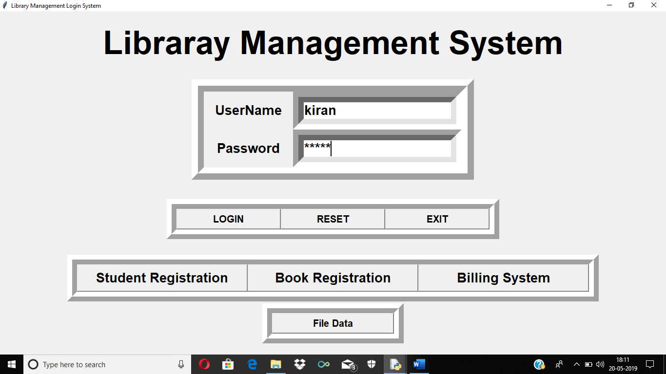
5.2 Student Registration Form
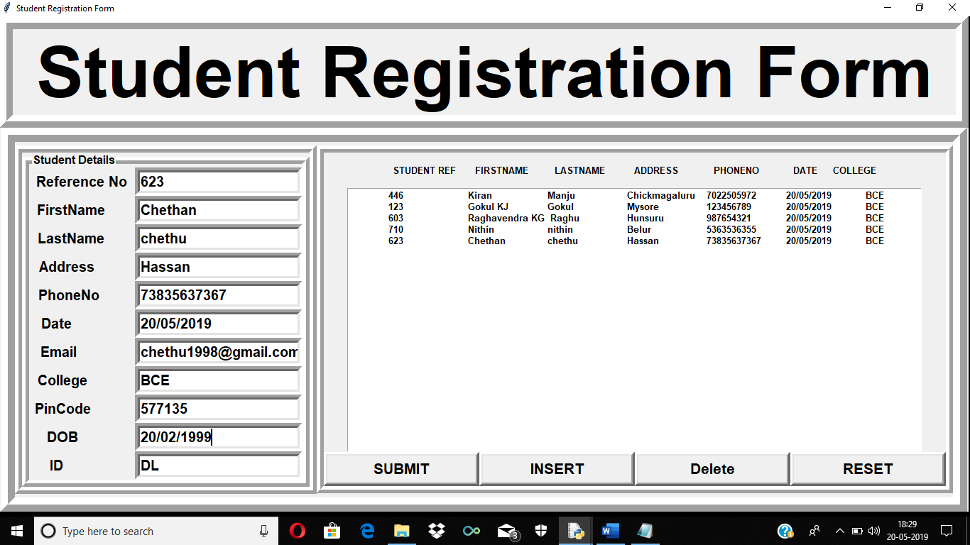

5.3 Book Registration Form
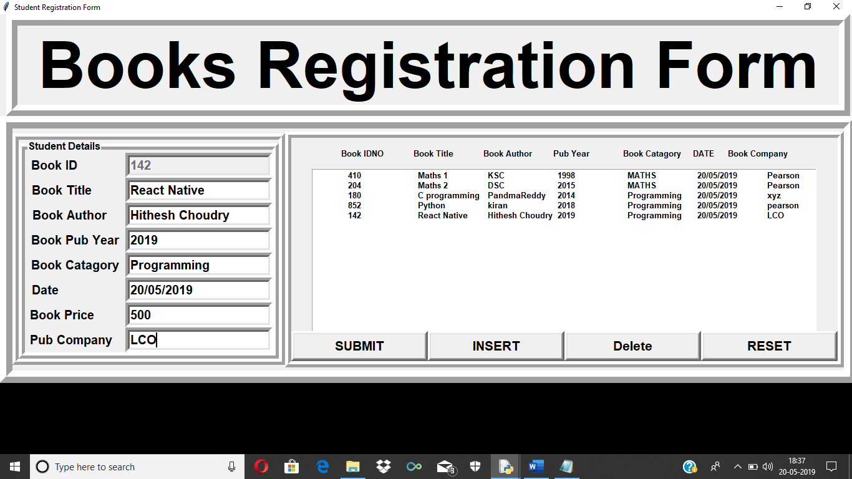

5.4 Billing Form
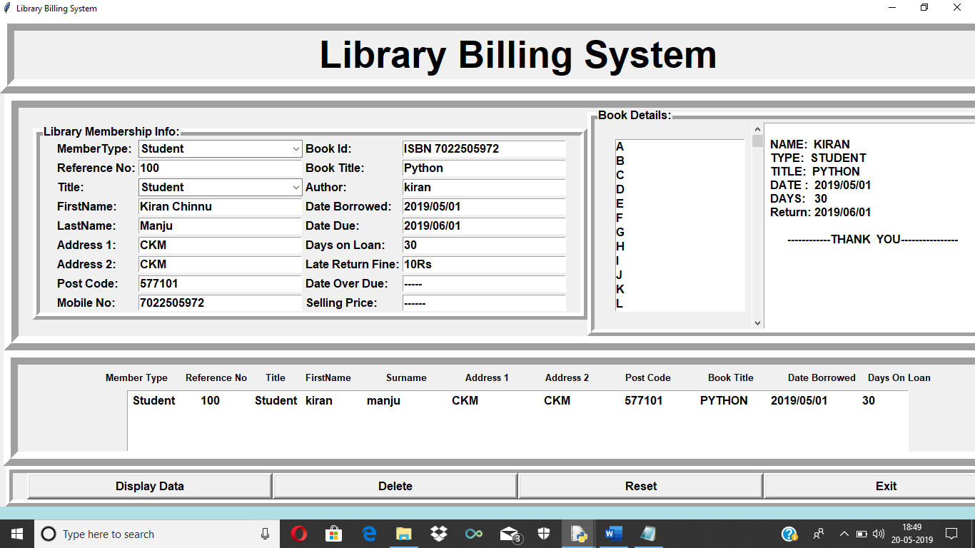

5.5 Student Data File:
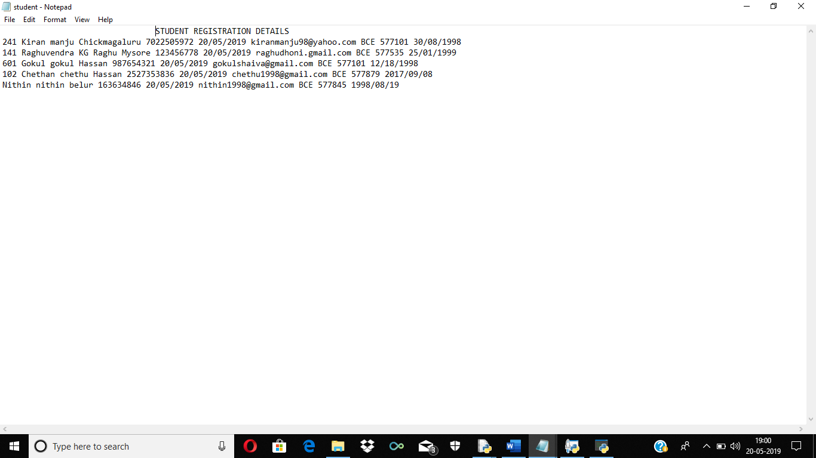

5.6 Book Data File
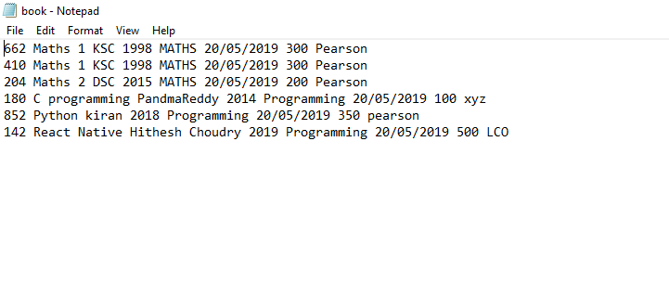

CONCLUSION
Library Managament System is a project which aims in developing a computerized system to maintain all the daily work of library. This project has many features which are generally not available in normal library management system like it has a admin login through which the admin can monitor whole system. Here the student can borrow the book and also he can purchase the book. All the records of this system is stored in text files safely.

REFERENCES
- Michael J Folk,Bill Zoellick,Greg Riccard File Structures An Object Oriented Approach with C++,3rd Edition,Pearson Education, 1998.
- Martin C. Brown: File Structures using python Complete Reference, 2018.

